Alexander Cannell

CSIA 6210

Professor Linn

**Week 6: Enumeration**

﻿**1) Take a screenshot and list 3 pages that were found through spidering**

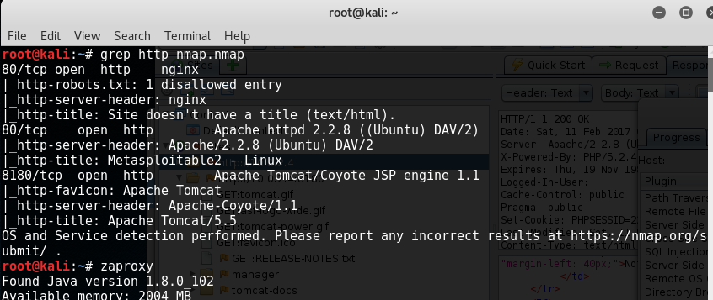

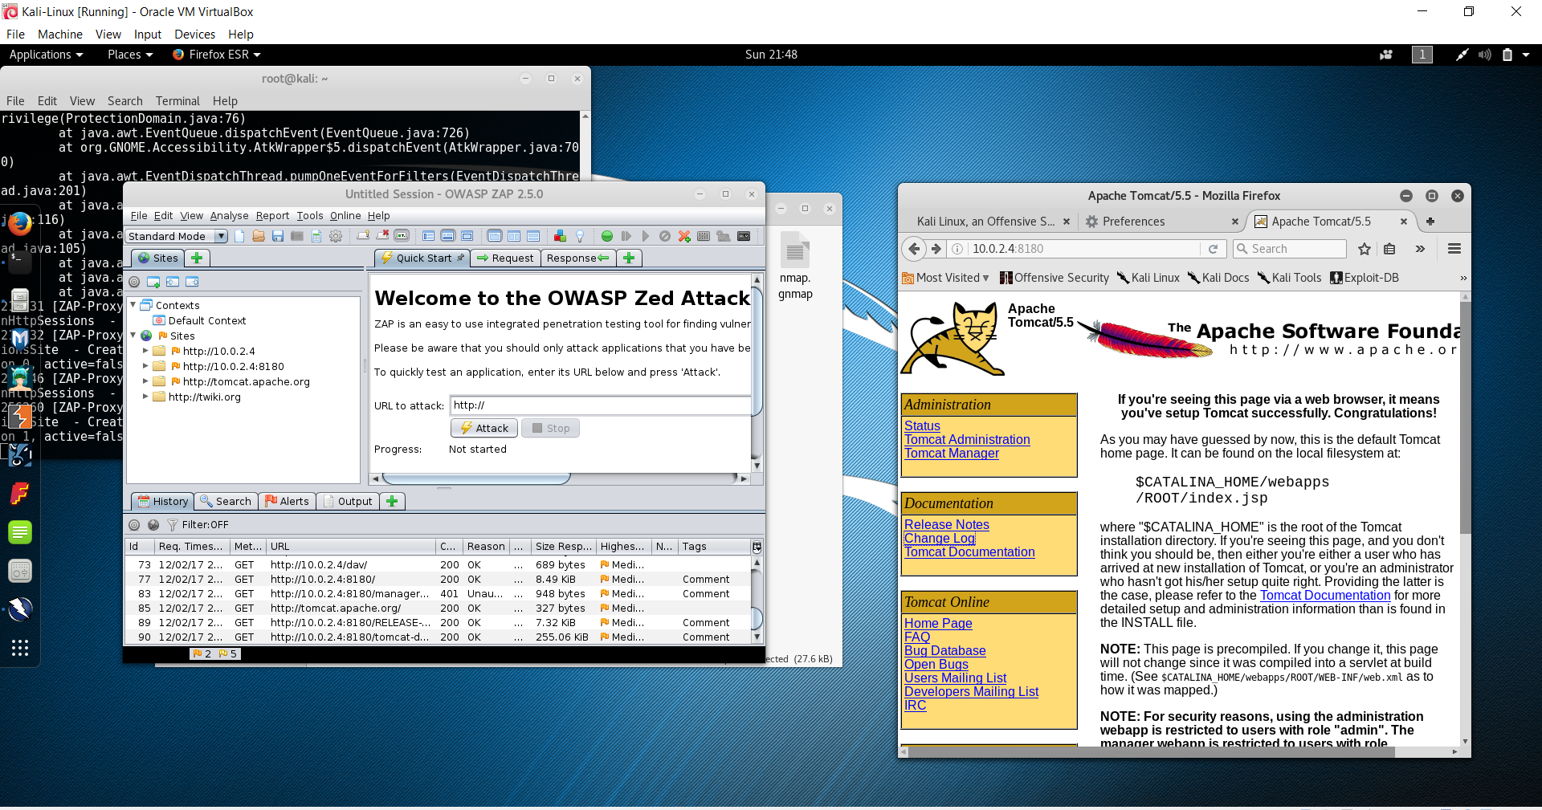

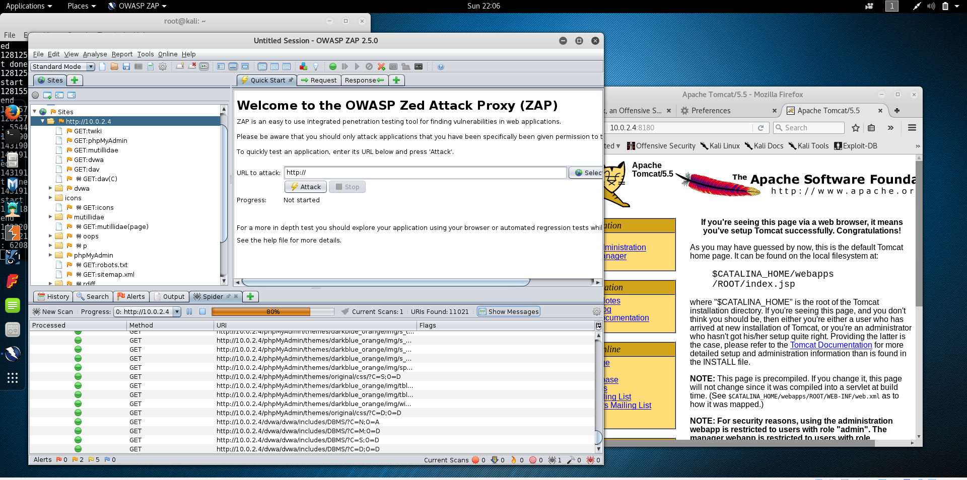

Spidering I got alot of websites, the three I choose was <http://10.0.2.4/dav/>, <http://10.0.2.4/mutillidae>, and <http://10.0.2.4/phpMyAdmin/index.php> 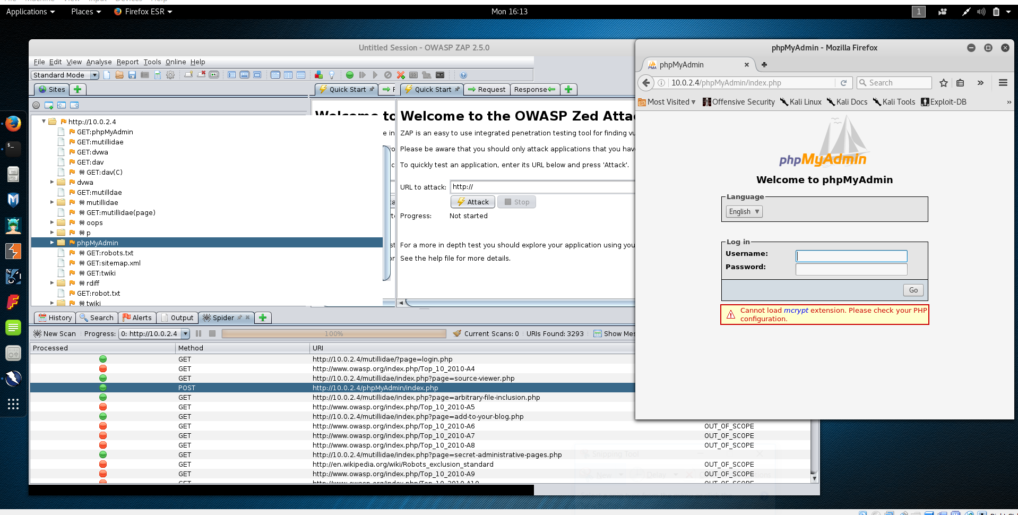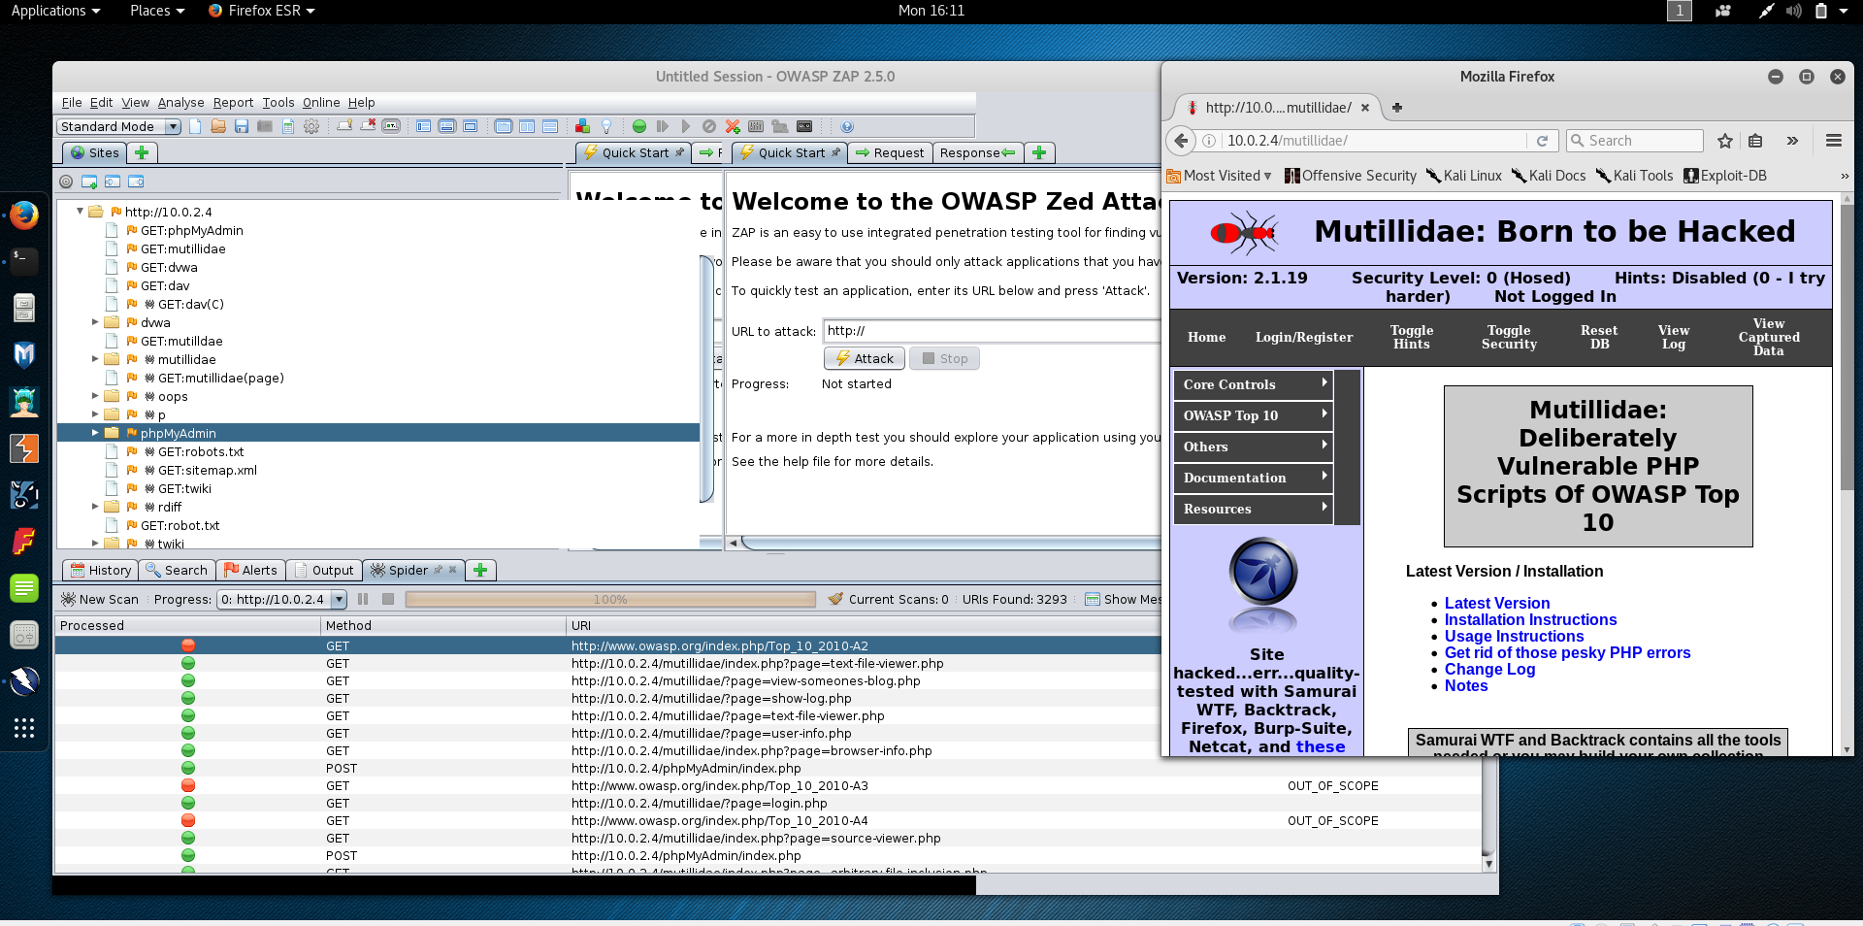

**2) What is the most common vulnerability found on the site?**

I tried to complete a full scan but it didnt happen. My scans lagged out three times. The four Alerts that I got were Cross Site Scripting(Reflected), External Redirect, Remote OS Command Injection, SQL Injection, Server Side Include, and Path Traversal. The most common vulnerability I found was Cross Site Scripting(reflected) with about 2245 critical alerts.

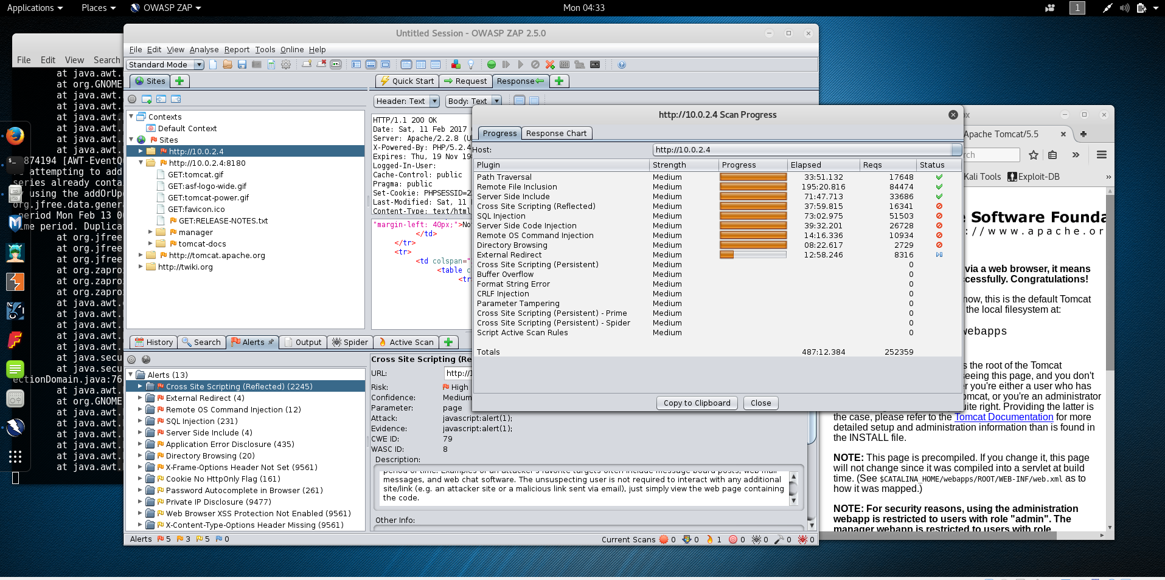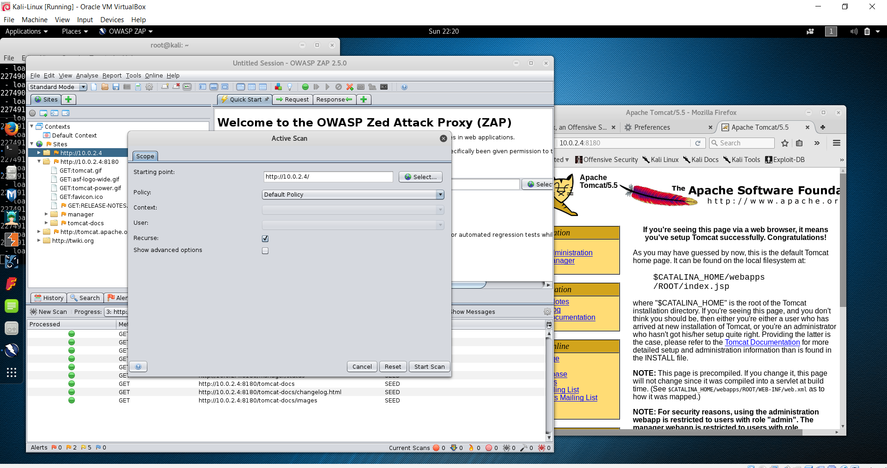

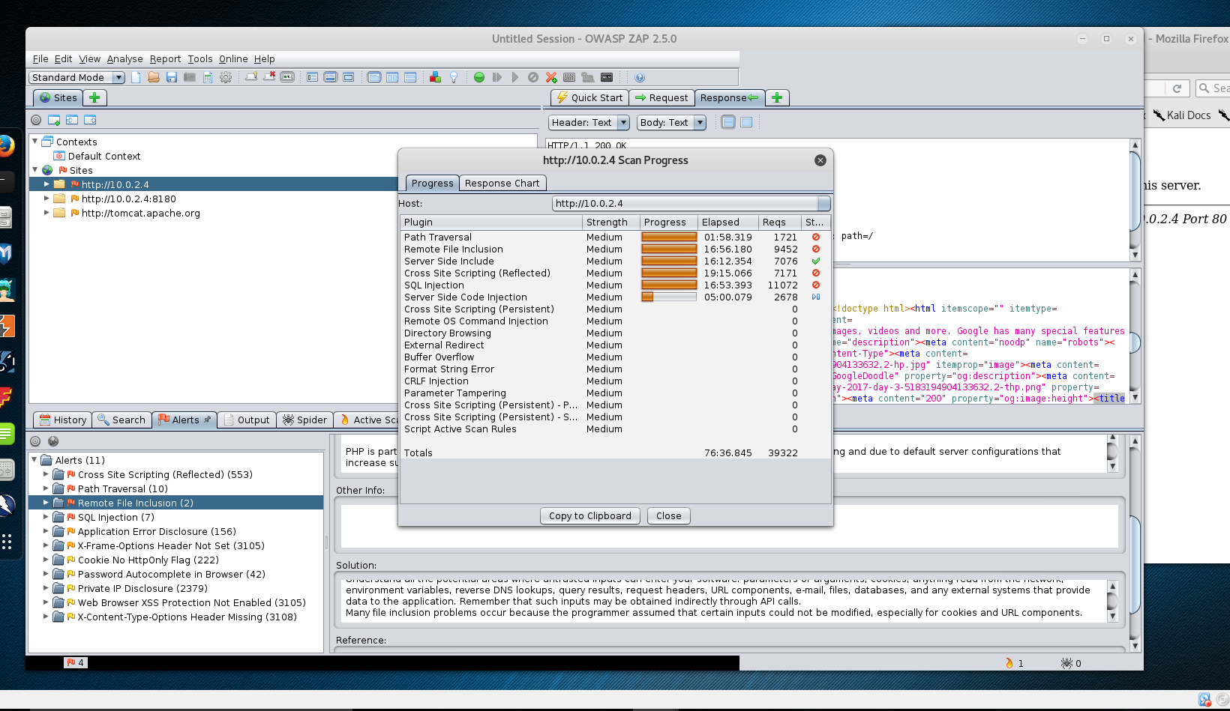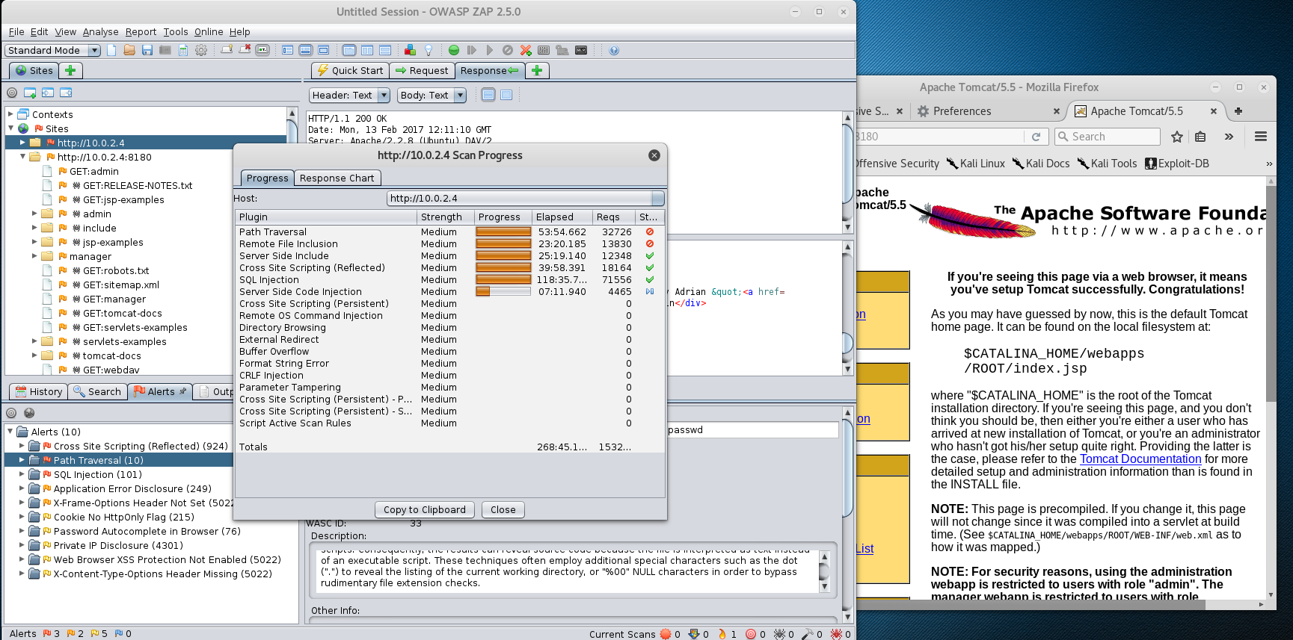

**3) What did the Tomcat username/password end up being? (take a screenshot to show how you got there)**

Setting the target host to 10.0.2.4, setting the target port to HTTP port 8180, and setting the threads to a count of 10 for speed.

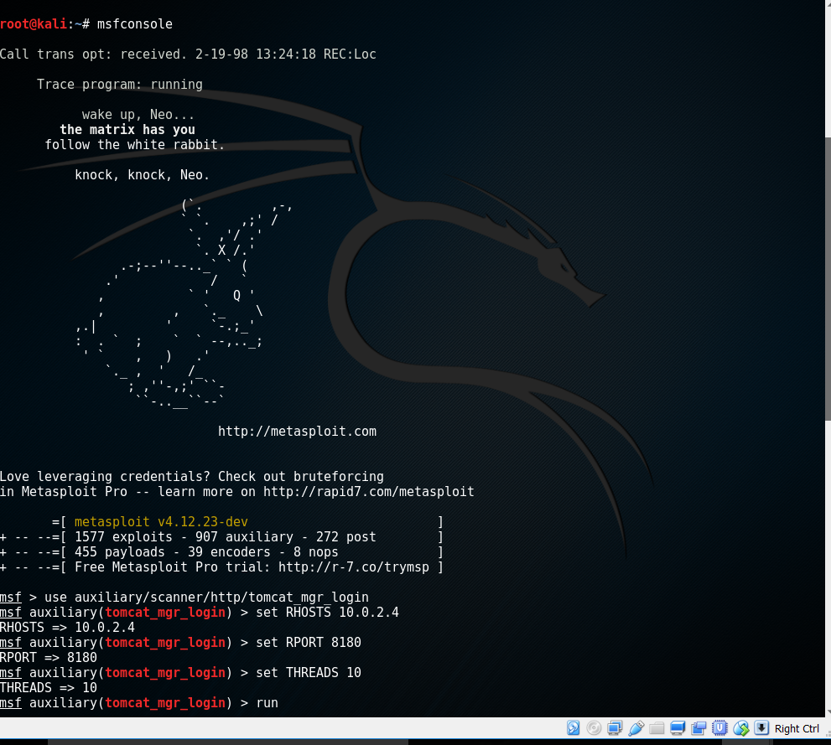

Output:

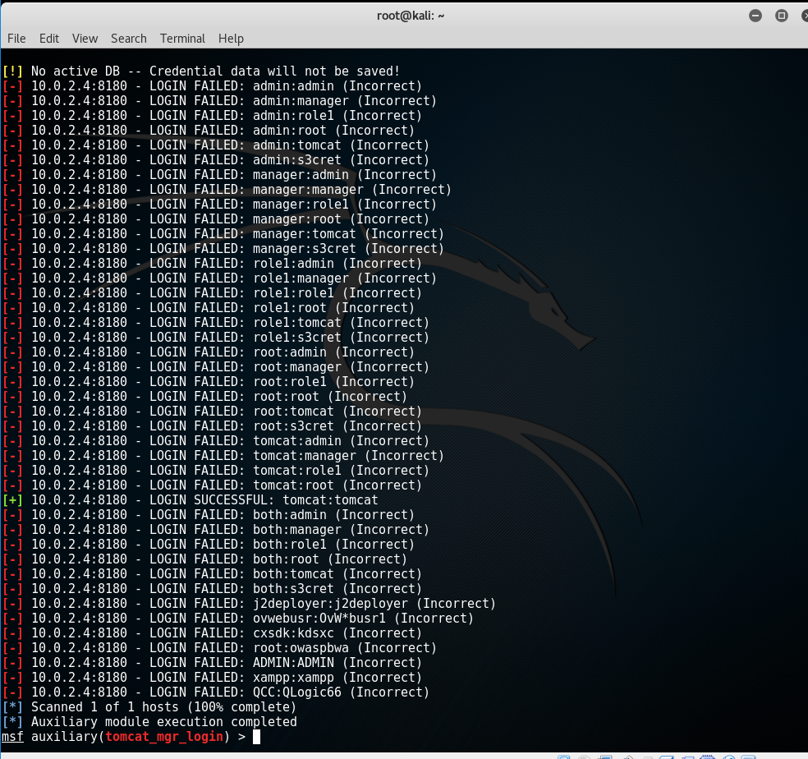

The Username is tomcat and the password is tomcat

**4) Name 4 vulnerable applications which you found through scanning.**

Cross Site Scripting (Reflected):

Critical Alert

<http://10.0.2.4/mutillidae/index.php?page=javascript%3Aalert%281%29%3B>

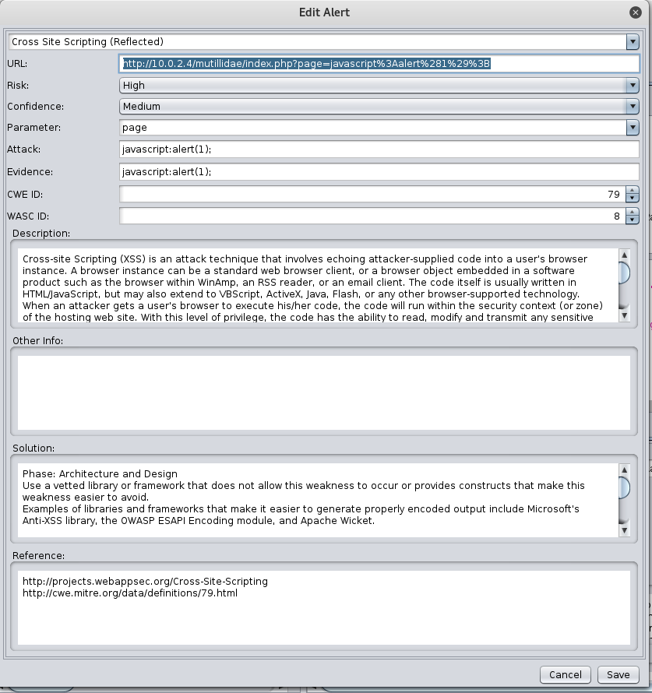

External Redirect:

Critical Alert

URL= <http://10.0.2.4/mutillidae/index.php?forwardurl=590850204893856259.owasp.org&page=redirectandlog.php>

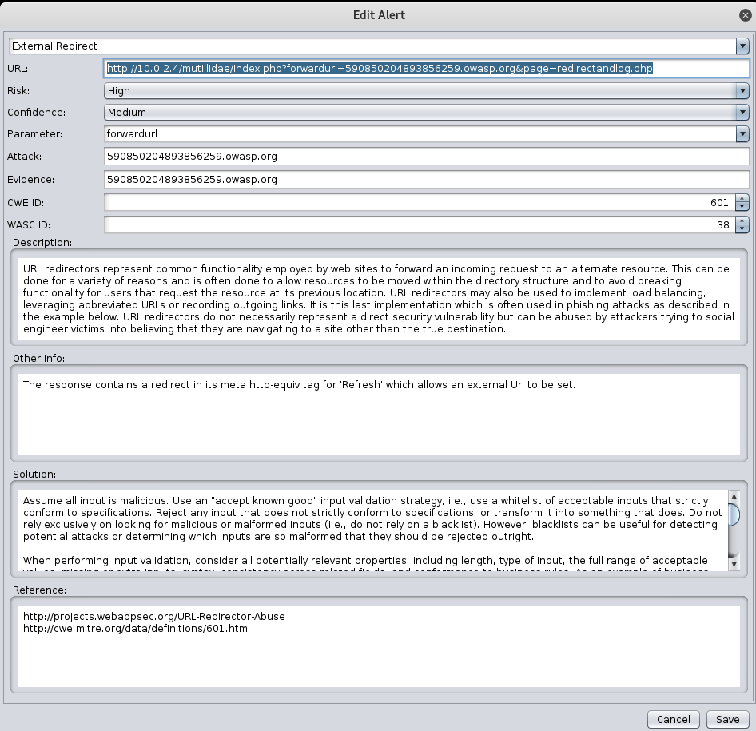

Path Traversal:

Critical Alert

URL = <http://10.0.2.4/mutillidae/index.php?page=%2Fetc%2Fpasswd>

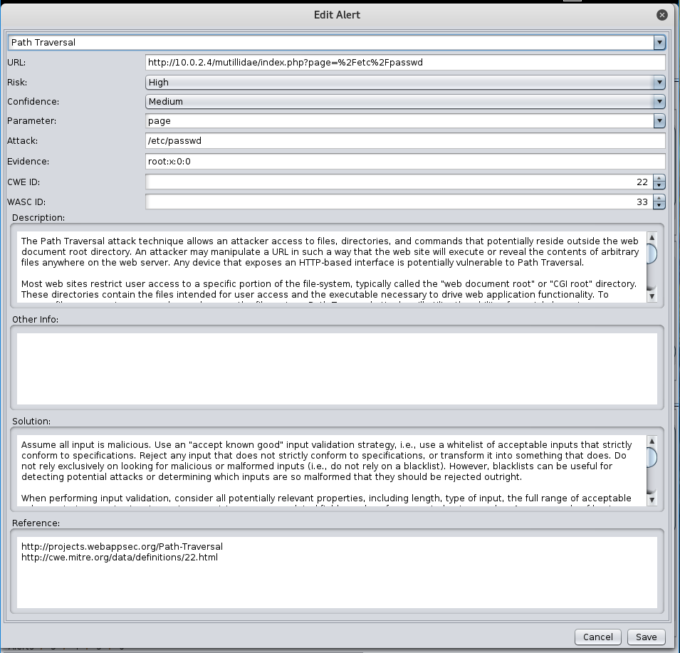

Remote File Inclusion:

Critical Alert

URL = <http://10.0.2.4/mutillidae/index.php?page=text-file-viewer.php>

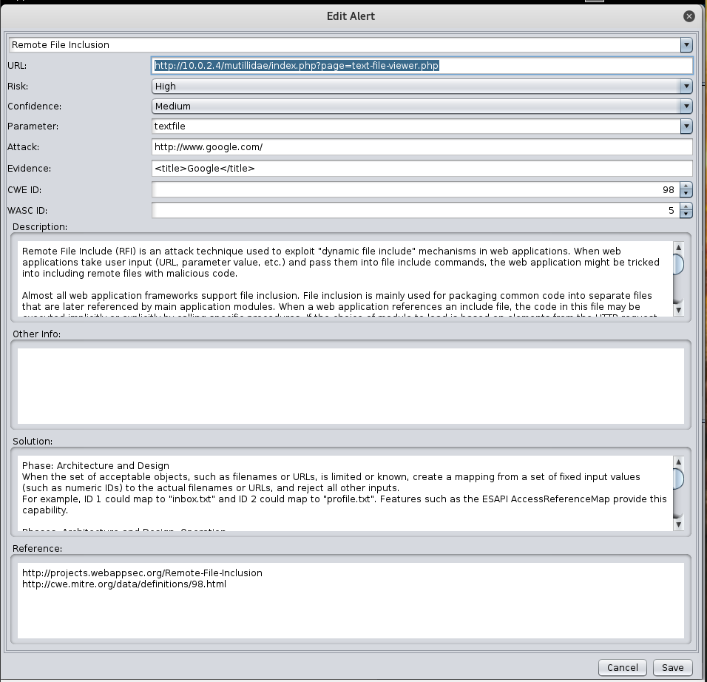

Remote OS Command Injection:

Critical Alert

URL=<http://10.0.2.4/mutillidae/index.php?page=dns-lookup.php>

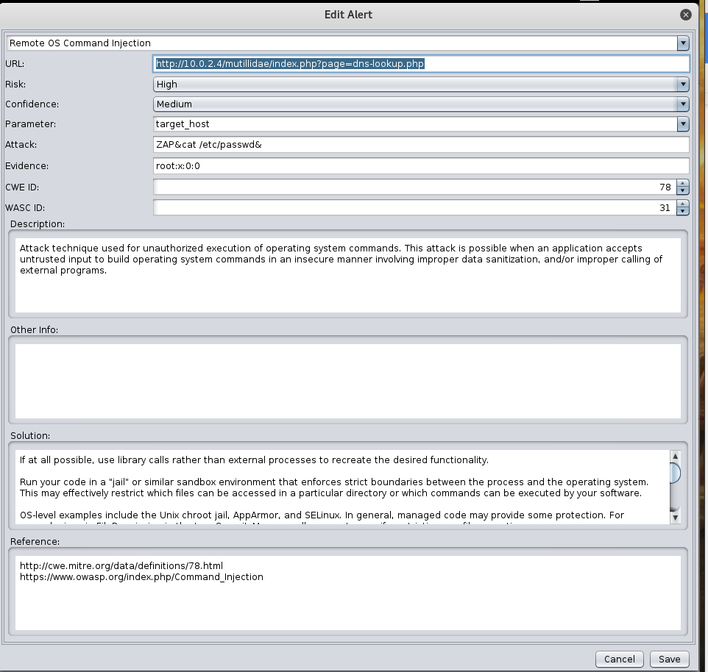

**root@kali**:**~**# nmap 10.0.2.0/24  
  
Starting Nmap 7.25BETA2 ( https://nmap.org ) at 2017-02-11 17:10 EST  
Nmap scan report for 10.0.2.1  
Host is up (0.00013s latency).  
Not shown: 999 closed ports  
PORT STATE SERVICE  
53/tcp open domain  
MAC Address: 52:54:00:12:35:00 (QEMU virtual NIC)  
  
Nmap scan report for 10.0.2.2  
Host is up (1.0s latency).  
Not shown: 996 closed ports  
PORT STATE SERVICE  
135/tcp open msrpc  
445/tcp open microsoft-ds  
5357/tcp open wsdapi  
65000/tcp open unknown  
MAC Address: 52:54:00:12:35:00 (QEMU virtual NIC)  
  
Nmap scan report for 10.0.2.3  
Host is up (0.00023s latency).  
All 1000 scanned ports on 10.0.2.3 are filtered  
MAC Address: 08:00:27:59:FD:84 (Oracle VirtualBox virtual NIC)  
  
Nmap scan report for 10.0.2.4  
Host is up (0.00018s latency).  
Not shown: 977 closed ports  
PORT STATE SERVICE  
21/tcp open ftp  
22/tcp open ssh  
23/tcp open telnet  
25/tcp open smtp  
53/tcp open domain  
80/tcp open http  
111/tcp open rpcbind  
139/tcp open netbios-ssn  
445/tcp open microsoft-ds  
512/tcp open exec  
513/tcp open login  
514/tcp open shell  
1099/tcp open rmiregistry  
1524/tcp open ingreslock  
2049/tcp open nfs  
2121/tcp open ccproxy-ftp  
3306/tcp open mysql  
5432/tcp open postgresql  
5900/tcp open vnc  
6000/tcp open X11  
6667/tcp open irc  
8009/tcp open ajp13  
8180/tcp open unknown  
MAC Address: 08:00:27:3E:5B:40 (Oracle VirtualBox virtual NIC)  
  
Nmap scan report for 10.0.2.15  
Host is up (0.0000030s latency).  
All 1000 scanned ports on 10.0.2.15 are closed  
  
Nmap done: 256 IP addresses (5 hosts up) scanned in 51.47 seconds

**root@kali**:**~**# enum4linux -S 10.0.2.4  
Starting enum4linux v0.8.9 ( http://labs.portcullis.co.uk/application/enum4linux/ ) on Sat Feb 11 17:11:58 2017  
  
 ==========================   
| Target Information |  
 ==========================   
Target ........... 10.0.2.4  
RID Range ........ 500-550,1000-1050  
Username ......... ''  
Password ......... ''  
Known Usernames .. administrator, guest, krbtgt, domain admins, root, bin, none  
  
  
 ================================================   
| Enumerating Workgroup/Domain on 10.0.2.4 |  
 ================================================   
[+] Got domain/workgroup name: WORKGROUP  
  
 =================================   
| Session Check on 10.0.2.4 |  
 =================================   
[+] Server 10.0.2.4 allows sessions using username '', password ''  
  
 =======================================   
| Getting domain SID for 10.0.2.4 |  
 =======================================   
Domain Name: WORKGROUP  
Domain Sid: (NULL SID)  
[+] Can't determine if host is part of domain or part of a workgroup  
  
 =====================================   
| Share Enumeration on 10.0.2.4 |  
 =====================================   
WARNING: The "syslog" option is deprecated  
Domain=[WORKGROUP] OS=[Unix] Server=[Samba 3.0.20-Debian]  
Domain=[WORKGROUP] OS=[Unix] Server=[Samba 3.0.20-Debian]  
  
 Sharename Type Comment  
 --------- ---- -------  
 print$ Disk Printer Drivers  
 tmp Disk oh noes!  
 opt Disk   
 IPC$ IPC IPC Service (metasploitable server (Samba 3.0.20-Debian))  
 ADMIN$ IPC IPC Service (metasploitable server (Samba 3.0.20-Debian))  
  
 Server Comment  
 --------- -------  
 METASPLOITABLE metasploitable server (Samba 3.0.20-Debian)  
  
 Workgroup Master  
 --------- -------  
 WORKGROUP METASPLOITABLE  
  
[+] Attempting to map shares on 10.0.2.4  
//10.0.2.4/print$ Mapping: DENIED, Listing: N/A  
//10.0.2.4/tmp Mapping: OK, Listing: OK  
//10.0.2.4/opt Mapping: DENIED, Listing: N/A  
//10.0.2.4/IPC$ [E] Can't understand response:  
WARNING: The "syslog" option is deprecated  
Domain=[WORKGROUP] OS=[Unix] Server=[Samba 3.0.20-Debian]  
NT_STATUS_NETWORK_ACCESS_DENIED listing \*  
//10.0.2.4/ADMIN$ Mapping: DENIED, Listing: N/A  
enum4linux complete on Sat Feb 11 17:11:58 2017  
  
**root@kali**:**~**# smbclient -L 10.0.2.4 -N  
WARNING: The "syslog" option is deprecated  
Anonymous login successful  
Domain=[WORKGROUP] OS=[Unix] Server=[Samba 3.0.20-Debian]  
  
 Sharename Type Comment  
 --------- ---- -------  
 print$ Disk Printer Drivers  
 tmp Disk oh noes!  
 opt Disk   
 IPC$ IPC IPC Service (metasploitable server (Samba 3.0.20-Debian))  
 ADMIN$ IPC IPC Service (metasploitable server (Samba 3.0.20-Debian))  
Anonymous login successful  
Domain=[WORKGROUP] OS=[Unix] Server=[Samba 3.0.20-Debian]  
  
 Server Comment  
 --------- -------  
 METASPLOITABLE metasploitable server (Samba 3.0.20-Debian)  
  
 Workgroup Master  
 --------- -------  
 WORKGROUP METASPLOITABLE  
﻿

**root@kali**:**~**# smbclient -L 10.0.2.4 -N  
WARNING: The "syslog" option is deprecated  
Anonymous login successful  
Domain=[WORKGROUP] OS=[Unix] Server=[Samba 3.0.20-Debian]  
  
 Sharename Type Comment  
 --------- ---- -------  
 print$ Disk Printer Drivers  
 tmp Disk oh noes!  
 opt Disk   
 IPC$ IPC IPC Service (metasploitable server (Samba 3.0.20-Debian))  
 ADMIN$ IPC IPC Service (metasploitable server (Samba 3.0.20-Debian))  
Anonymous login successful  
Domain=[WORKGROUP] OS=[Unix] Server=[Samba 3.0.20-Debian]  
  
 Server Comment  
 --------- -------  
 METASPLOITABLE metasploitable server (Samba 3.0.20-Debian)  
  
 Workgroup Master  
 --------- -------  
 WORKGROUP METASPLOITABLE  
  
**root@kali**:**~**# msfconsole -q  
msf > use auxiliary/scanner/smb/smb_enumshares  
msf auxiliary(**smb_enumshares**) > set RHOSTS 10.0.2.4  
RHOSTS => 10.0.2.4  
msf auxiliary(**smb_enumshares**) > run  
  
**[+]** 10.0.2.4:139 - print$ - (DISK) Printer Drivers  
**[+]** 10.0.2.4:139 - tmp - (DISK) oh noes!  
**[+]** 10.0.2.4:139 - opt - (DISK)   
**[+]** 10.0.2.4:139 - IPC$ - (IPC) IPC Service (metasploitable server (Samba 3.0.20-Debian))  
**[+]** 10.0.2.4:139 - ADMIN$ - (IPC) IPC Service (metasploitable server (Samba 3.0.20-Debian))  
**[*]** Scanned 1 of 1 hosts (100% complete)  
**[*]** Auxiliary module execution completed  
msf auxiliary(**smb_enumshares**) > exit

**root@kali**:**~**# enum4linux -U 10.0.2.4  
Starting enum4linux v0.8.9 ( http://labs.portcullis.co.uk/application/enum4linux/ ) on Sat Feb 11 17:21:17 2017  
  
 ==========================   
| Target Information |  
 ==========================   
Target ........... 10.0.2.4  
RID Range ........ 500-550,1000-1050  
Username ......... ''  
Password ......... ''  
Known Usernames .. administrator, guest, krbtgt, domain admins, root, bin, none  
  
  
 ================================================   
| Enumerating Workgroup/Domain on 10.0.2.4 |  
 ================================================   
[+] Got domain/workgroup name: WORKGROUP  
  
 =================================   
| Session Check on 10.0.2.4 |  
 =================================   
[+] Server 10.0.2.4 allows sessions using username '', password ''  
  
 =======================================   
| Getting domain SID for 10.0.2.4 |  
 =======================================   
Domain Name: WORKGROUP  
Domain Sid: (NULL SID)  
[+] Can't determine if host is part of domain or part of a workgroup  
  
 =========================   
| Users on 10.0.2.4 |  
 =========================   
index: 0x1 RID: 0x3f2 acb: 0x00000011 Account: games Name: games Desc: (null)  
index: 0x2 RID: 0x1f5 acb: 0x00000011 Account: nobody Name: nobody Desc: (null)  
index: 0x3 RID: 0x4ba acb: 0x00000011 Account: bind Name: (null) Desc: (null)  
index: 0x4 RID: 0x402 acb: 0x00000011 Account: proxy Name: proxy Desc: (null)  
index: 0x5 RID: 0x4b4 acb: 0x00000011 Account: syslog Name: (null) Desc: (null)  
index: 0x6 RID: 0xbba acb: 0x00000010 Account: user Name: just a user,111,, Desc: (null)  
index: 0x7 RID: 0x42a acb: 0x00000011 Account: www-data Name: www-data Desc: (null)  
index: 0x8 RID: 0x3e8 acb: 0x00000011 Account: root Name: root Desc: (null)  
index: 0x9 RID: 0x3fa acb: 0x00000011 Account: news Name: news Desc: (null)  
index: 0xa RID: 0x4c0 acb: 0x00000011 Account: postgres Name: PostgreSQL administrator,,, Desc: (null)  
index: 0xb RID: 0x3ec acb: 0x00000011 Account: bin Name: bin Desc: (null)  
index: 0xc RID: 0x3f8 acb: 0x00000011 Account: mail Name: mail Desc: (null)  
index: 0xd RID: 0x4c6 acb: 0x00000011 Account: distccd Name: (null) Desc: (null)  
index: 0xe RID: 0x4ca acb: 0x00000011 Account: proftpd Name: (null) Desc: (null)  
index: 0xf RID: 0x4b2 acb: 0x00000011 Account: dhcp Name: (null) Desc: (null)  
index: 0x10 RID: 0x3ea acb: 0x00000011 Account: daemon Name: daemon Desc: (null)  
index: 0x11 RID: 0x4b8 acb: 0x00000011 Account: sshd Name: (null) Desc: (null)  
index: 0x12 RID: 0x3f4 acb: 0x00000011 Account: man Name: man Desc: (null)  
index: 0x13 RID: 0x3f6 acb: 0x00000011 Account: lp Name: lp Desc: (null)  
index: 0x14 RID: 0x4c2 acb: 0x00000011 Account: mysql Name: MySQL Server,,, Desc: (null)  
index: 0x15 RID: 0x43a acb: 0x00000011 Account: gnats Name: Gnats Bug-Reporting System (admin) Desc: (null)  
index: 0x16 RID: 0x4b0 acb: 0x00000011 Account: libuuid Name: (null) Desc: (null)  
index: 0x17 RID: 0x42c acb: 0x00000011 Account: backup Name: backup Desc: (null)  
index: 0x18 RID: 0xbb8 acb: 0x00000010 Account: msfadmin Name: msfadmin,,, Desc: (null)  
index: 0x19 RID: 0x4c8 acb: 0x00000011 Account: telnetd Name: (null) Desc: (null)  
index: 0x1a RID: 0x3ee acb: 0x00000011 Account: sys Name: sys Desc: (null)  
index: 0x1b RID: 0x4b6 acb: 0x00000011 Account: klog Name: (null) Desc: (null)  
index: 0x1c RID: 0x4bc acb: 0x00000011 Account: postfix Name: (null) Desc: (null)  
index: 0x1d RID: 0xbbc acb: 0x00000011 Account: service Name: ,,, Desc: (null)  
index: 0x1e RID: 0x434 acb: 0x00000011 Account: list Name: Mailing List Manager Desc: (null)  
index: 0x1f RID: 0x436 acb: 0x00000011 Account: irc Name: ircd Desc: (null)  
index: 0x20 RID: 0x4be acb: 0x00000011 Account: ftp Name: (null) Desc: (null)  
index: 0x21 RID: 0x4c4 acb: 0x00000011 Account: tomcat55 Name: (null) Desc: (null)  
index: 0x22 RID: 0x3f0 acb: 0x00000011 Account: sync Name: sync Desc: (null)  
index: 0x23 RID: 0x3fc acb: 0x00000011 Account: uucp Name: uucp Desc: (null)  
  
user:[games] rid:[0x3f2]  
user:[nobody] rid:[0x1f5]  
user:[bind] rid:[0x4ba]  
user:[proxy] rid:[0x402]  
user:[syslog] rid:[0x4b4]  
user:[user] rid:[0xbba]  
user:[www-data] rid:[0x42a]  
user:[root] rid:[0x3e8]  
user:[news] rid:[0x3fa]  
user:[postgres] rid:[0x4c0]  
user:[bin] rid:[0x3ec]  
user:[mail] rid:[0x3f8]  
user:[distccd] rid:[0x4c6]  
user:[proftpd] rid:[0x4ca]  
user:[dhcp] rid:[0x4b2]  
user:[daemon] rid:[0x3ea]  
user:[sshd] rid:[0x4b8]  
user:[man] rid:[0x3f4]  
user:[lp] rid:[0x3f6]  
user:[mysql] rid:[0x4c2]  
user:[gnats] rid:[0x43a]  
user:[libuuid] rid:[0x4b0]  
user:[backup] rid:[0x42c]  
user:[msfadmin] rid:[0xbb8]  
user:[telnetd] rid:[0x4c8]  
user:[sys] rid:[0x3ee]  
user:[klog] rid:[0x4b6]  
user:[postfix] rid:[0x4bc]  
user:[service] rid:[0xbbc]  
user:[list] rid:[0x434]  
user:[irc] rid:[0x436]  
user:[ftp] rid:[0x4be]  
user:[tomcat55] rid:[0x4c4]  
user:[sync] rid:[0x3f0]  
user:[uucp] rid:[0x3fc]  
enum4linux complete on Sat Feb 11 17:21:17 2017  
  
**root@kali**:**~**# nmap -p 445 --script smb-enum-users 10.0.2.4  
  
Starting Nmap 7.25BETA2 ( https://nmap.org ) at 2017-02-11 17:24 EST  
Nmap scan report for 10.0.2.4  
Host is up (0.00034s latency).  
PORT STATE SERVICE  
445/tcp open microsoft-ds  
MAC Address: 08:00:27:3E:5B:40 (Oracle VirtualBox virtual NIC)  
  
Host script results:  
| smb-enum-users:   
| METASPLOITABLE\backup (RID: 1068)  
| Full name: backup  
| Flags: Normal user account, Account disabled  
| METASPLOITABLE\bin (RID: 1004)  
| Full name: bin  
| Flags: Normal user account, Account disabled  
| METASPLOITABLE\bind (RID: 1210)  
| Flags: Normal user account, Account disabled  
| METASPLOITABLE\daemon (RID: 1002)  
| Full name: daemon  
| Flags: Normal user account, Account disabled  
| METASPLOITABLE\dhcp (RID: 1202)  
| Flags: Normal user account, Account disabled  
| METASPLOITABLE\distccd (RID: 1222)  
| Flags: Normal user account, Account disabled  
| METASPLOITABLE\ftp (RID: 1214)  
| Flags: Normal user account, Account disabled  
| METASPLOITABLE\games (RID: 1010)  
| Full name: games  
| Flags: Normal user account, Account disabled  
| METASPLOITABLE\gnats (RID: 1082)  
| Full name: Gnats Bug-Reporting System (admin)  
| Flags: Normal user account, Account disabled  
| METASPLOITABLE\irc (RID: 1078)  
| Full name: ircd  
| Flags: Normal user account, Account disabled  
| METASPLOITABLE\klog (RID: 1206)  
| Flags: Normal user account, Account disabled  
| METASPLOITABLE\libuuid (RID: 1200)  
| Flags: Normal user account, Account disabled  
| METASPLOITABLE\list (RID: 1076)  
| Full name: Mailing List Manager  
| Flags: Normal user account, Account disabled  
| METASPLOITABLE\lp (RID: 1014)  
| Full name: lp  
| Flags: Normal user account, Account disabled  
| METASPLOITABLE\mail (RID: 1016)  
| Full name: mail  
| Flags: Normal user account, Account disabled  
| METASPLOITABLE\man (RID: 1012)  
| Full name: man  
| Flags: Normal user account, Account disabled  
| METASPLOITABLE\msfadmin (RID: 3000)  
| Full name: msfadmin,,,  
| Flags: Normal user account  
| METASPLOITABLE\mysql (RID: 1218)  
| Full name: MySQL Server,,,  
| Flags: Normal user account, Account disabled  
| METASPLOITABLE\news (RID: 1018)  
| Full name: news  
| Flags: Normal user account, Account disabled  
| METASPLOITABLE\nobody (RID: 501)  
| Full name: nobody  
| Flags: Normal user account, Account disabled  
| METASPLOITABLE\postfix (RID: 1212)  
| Flags: Normal user account, Account disabled  
| METASPLOITABLE\postgres (RID: 1216)  
| Full name: PostgreSQL administrator,,,  
| Flags: Normal user account, Account disabled  
| METASPLOITABLE\proftpd (RID: 1226)  
| Flags: Normal user account, Account disabled  
| METASPLOITABLE\proxy (RID: 1026)  
| Full name: proxy  
| Flags: Normal user account, Account disabled  
| METASPLOITABLE\root (RID: 1000)  
| Full name: root  
| Flags: Normal user account, Account disabled  
| METASPLOITABLE\service (RID: 3004)  
| Full name: ,,,  
| Flags: Normal user account, Account disabled  
| METASPLOITABLE\sshd (RID: 1208)  
| Flags: Normal user account, Account disabled  
| METASPLOITABLE\sync (RID: 1008)  
| Full name: sync  
| Flags: Normal user account, Account disabled  
| METASPLOITABLE\sys (RID: 1006)  
| Full name: sys  
| Flags: Normal user account, Account disabled  
| METASPLOITABLE\syslog (RID: 1204)  
| Flags: Normal user account, Account disabled  
| METASPLOITABLE\telnetd (RID: 1224)  
| Flags: Normal user account, Account disabled  
| METASPLOITABLE\tomcat55 (RID: 1220)  
| Flags: Normal user account, Account disabled  
| METASPLOITABLE\user (RID: 3002)  
| Full name: just a user,111,,  
| Flags: Normal user account  
| METASPLOITABLE\uucp (RID: 1020)  
| Full name: uucp  
| Flags: Normal user account, Account disabled  
| METASPLOITABLE\www-data (RID: 1066)  
| Full name: www-data  
|_ Flags: Normal user account, Account disabled  
  
Nmap done: 1 IP address (1 host up) scanned in 0.47 seconds

**5) Since this is the first run of this class and we're now a month in, give some brief honest feedback for what you think of the material so far and make suggestions of things that you think could be better or different.**

I am learning alot with these exercises, but I feel like there is something missing. I dont know what that is. Can we learn more about scripting and how that is used in pentesting. Also can we get a run down of stuff you use on a daily basis working as a pen tester. I really enjoy these hands on classes.